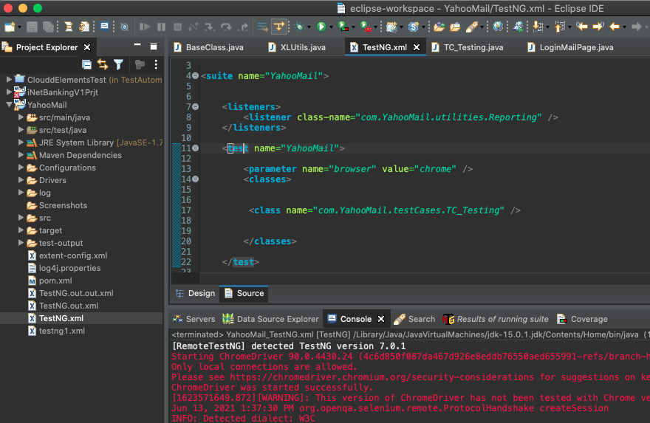



1. Open eclipse application
2. Double click on TestNG.xml file ( make sure that TestNG.xml file currently opened )
3. Then click on run button ( Green button)

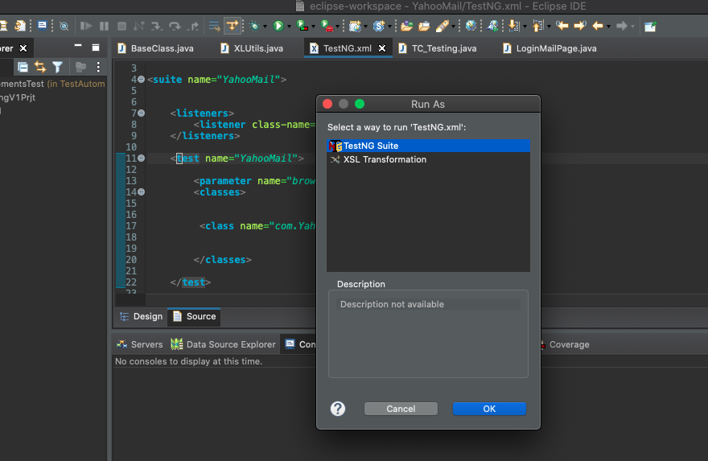

1. Click on Ok button ( Make sure TestNG Suite is selected ).

Then the execution begins

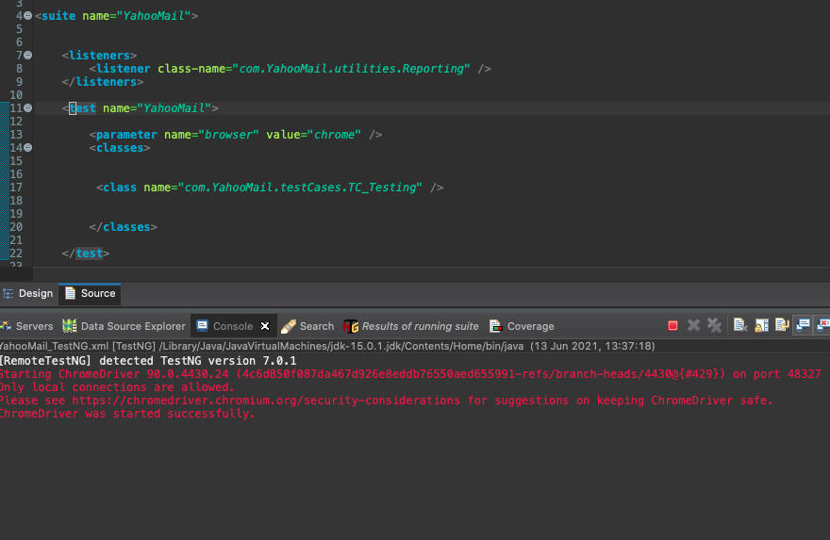



1. Once execution starts you can see the above “ Chrome was started successfully “message in console.
2. If the execution goes weird or any misbehaviour of execution you can Click on above red stop button.

Follow the same steps and re-run

**Data setting steps :**

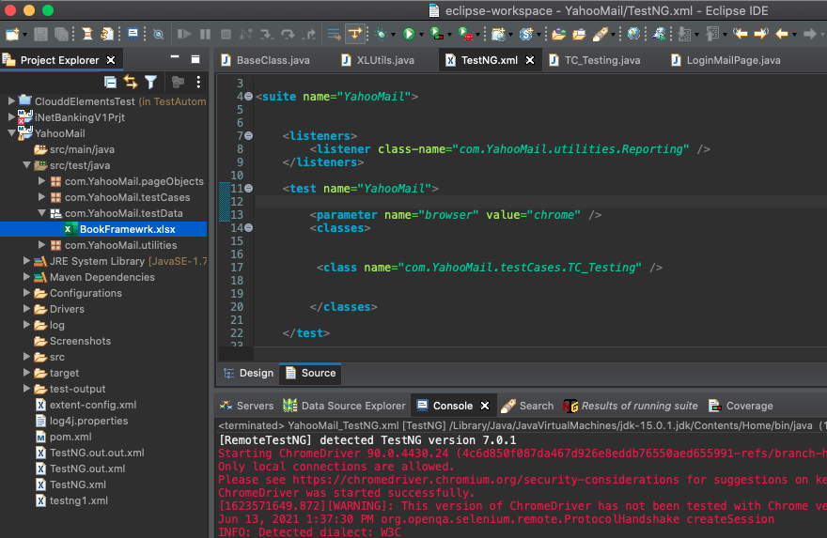



1. Open the BookFramewrk.xlsx in windows explorer and change the data in Sheet1 and save. ( If we need to run with new data set ).